**One2N Assignment**

Github repo : <https://github.com/Shubham051997/One2nassignment/blob/main/README.md>

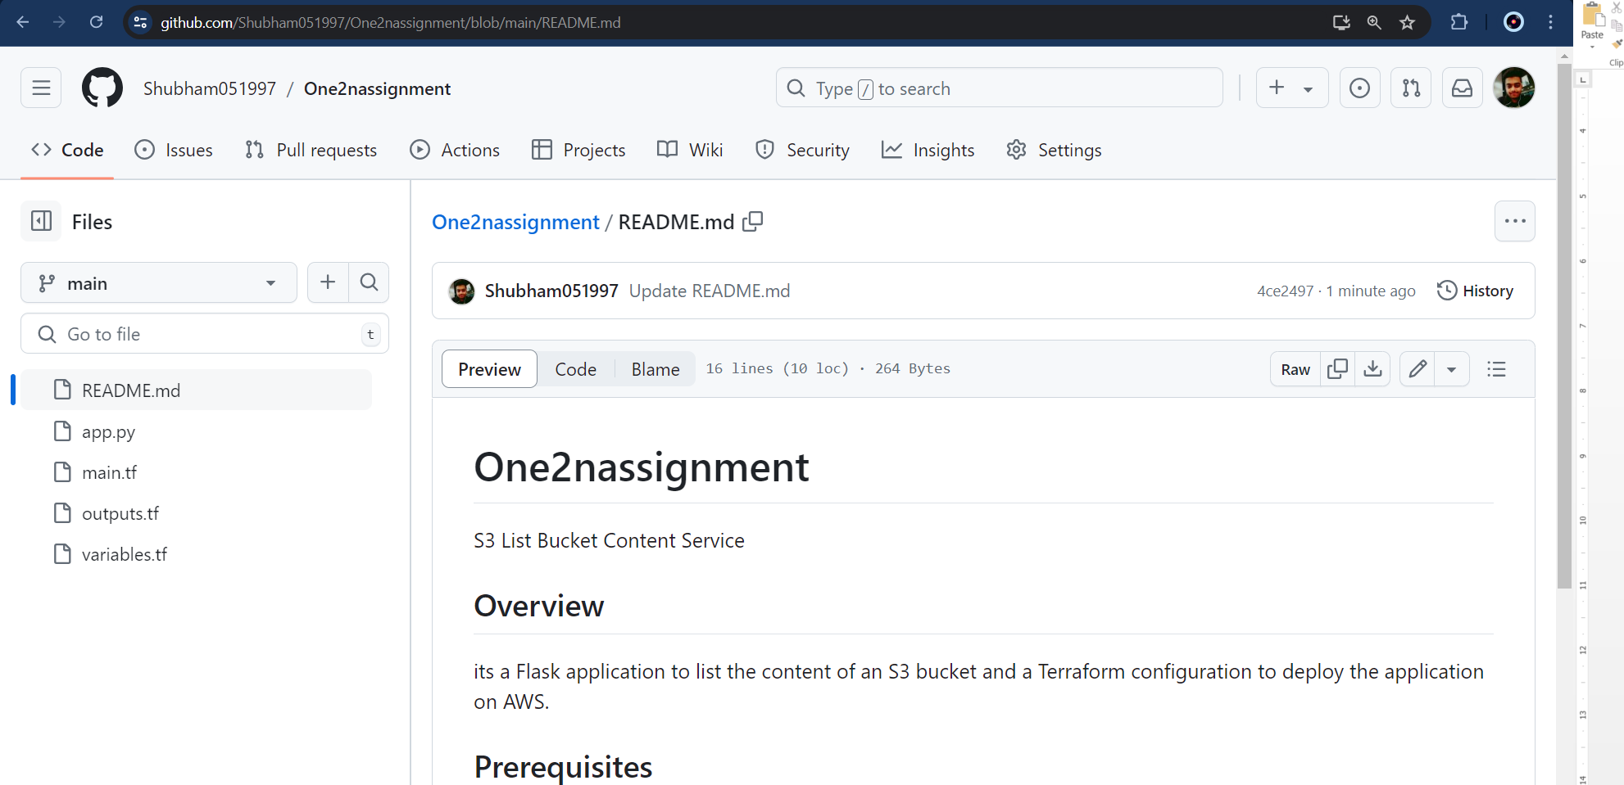  
  
  
1) From AWS root user we have created a user name one2n from IAM  
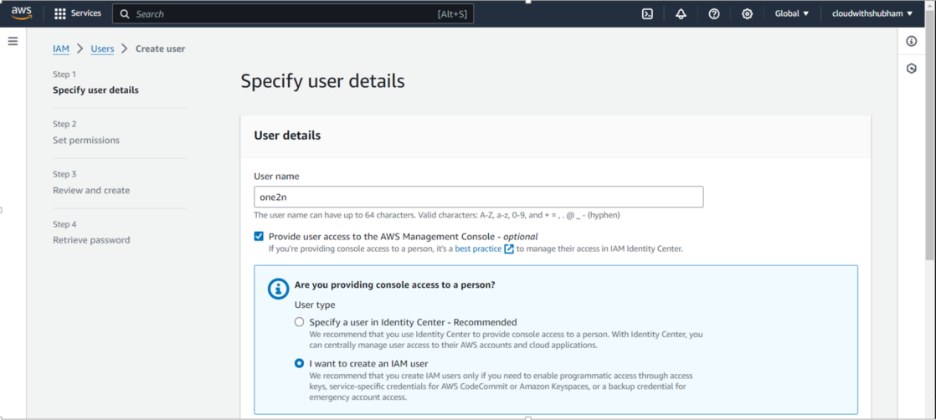   
  
Console url : <https://339713026722.signin.aws.amazon.com/console>  
  
Signed in as one2n user  
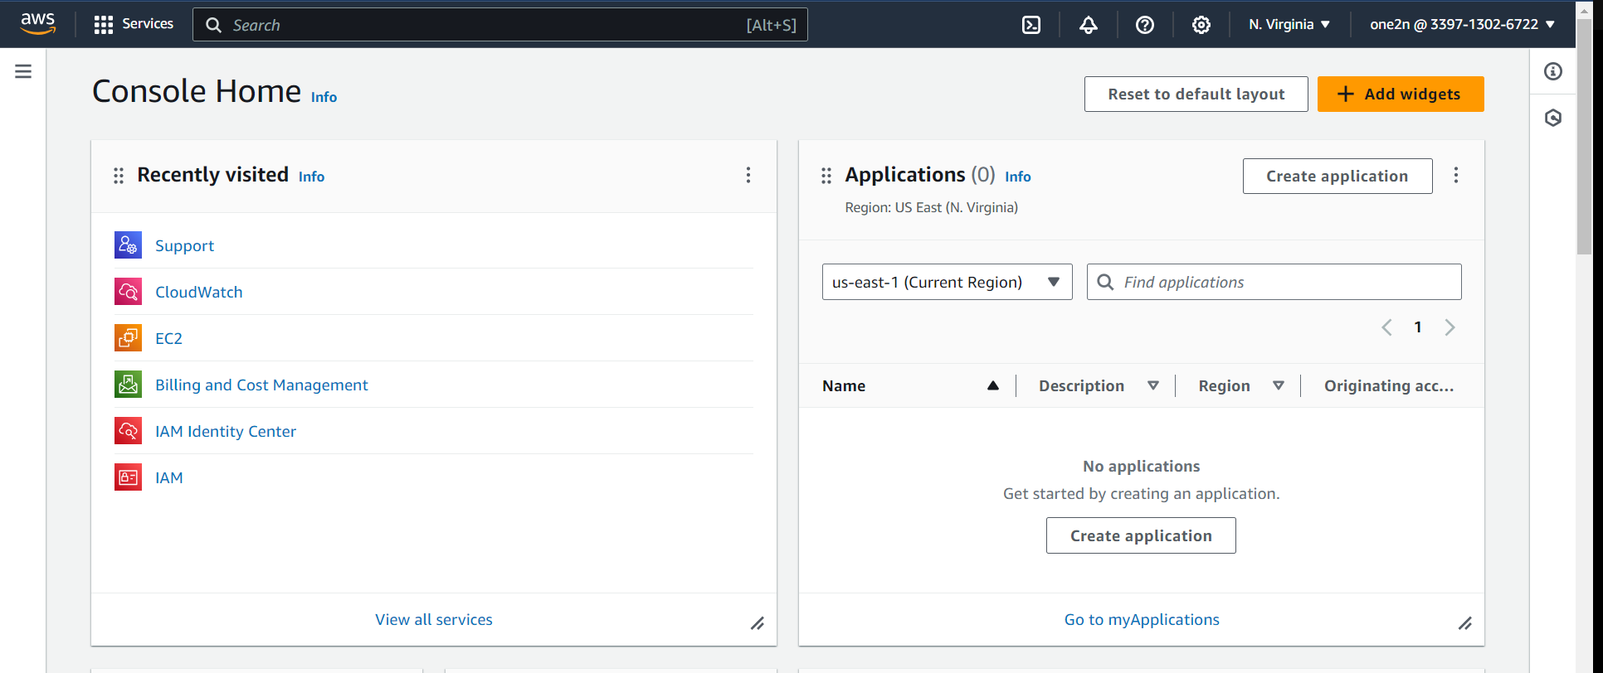

Bucket content  
  
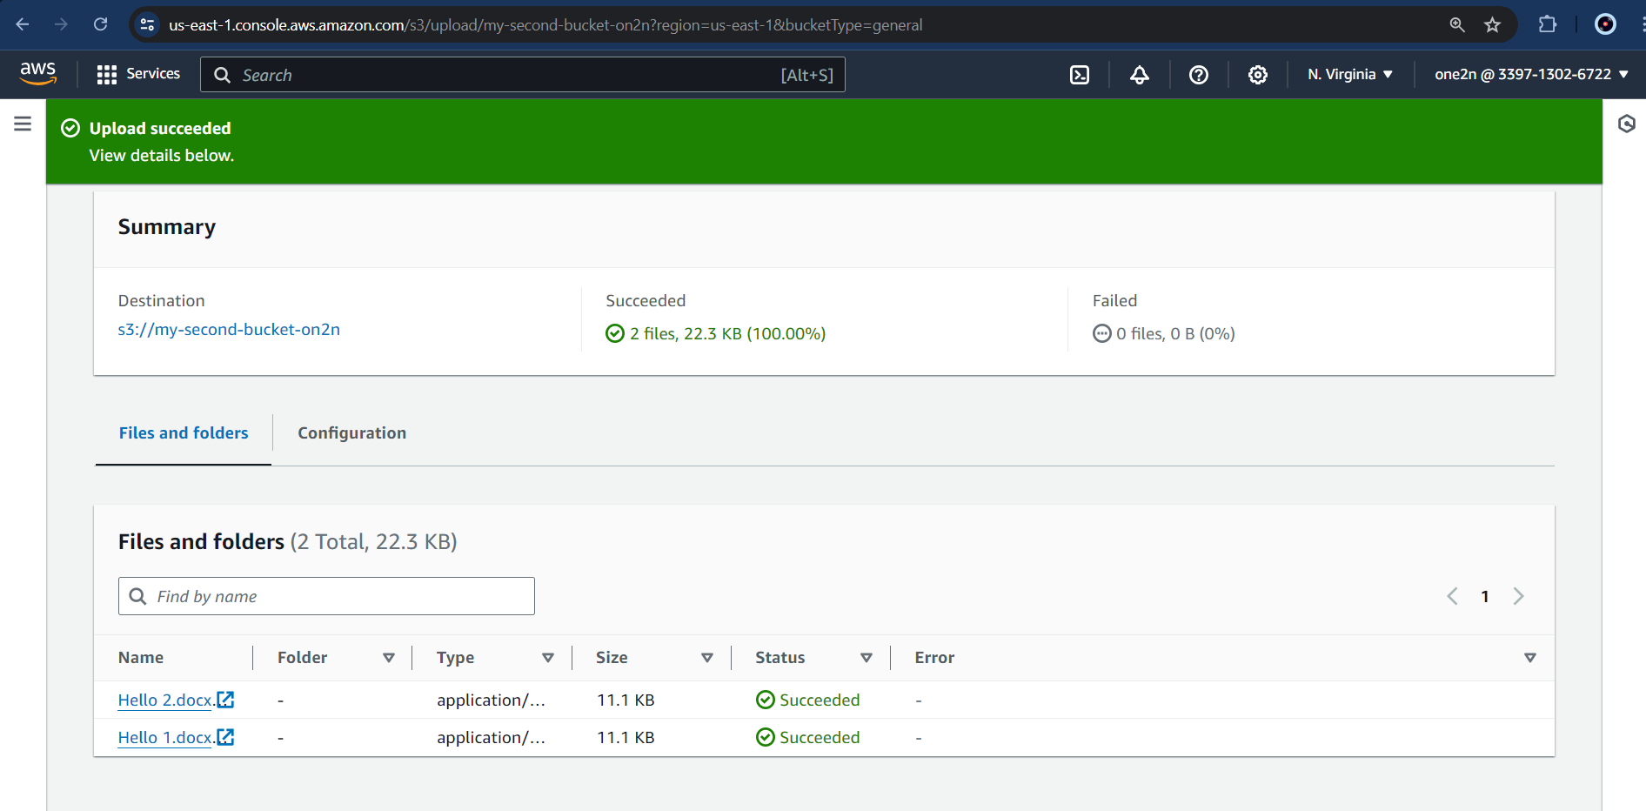

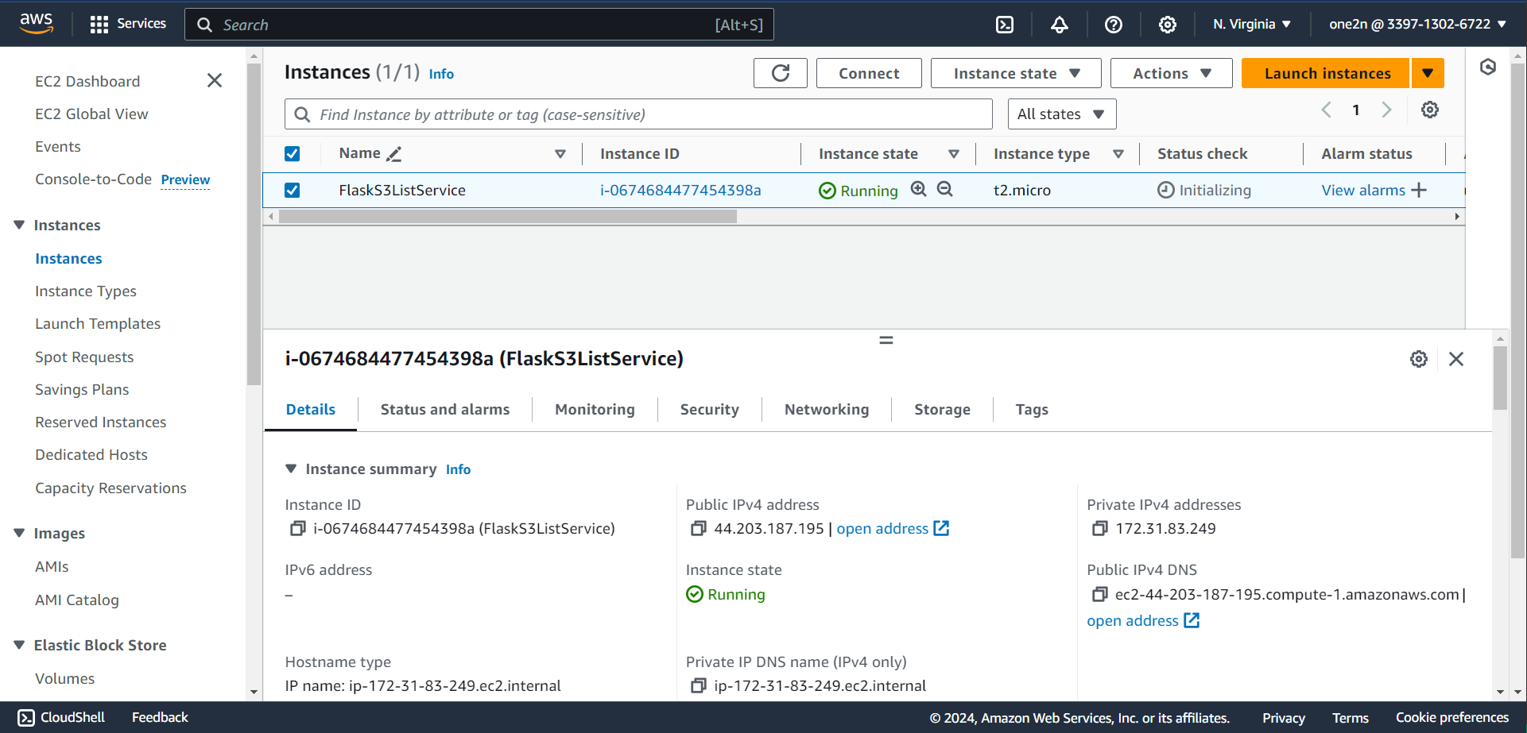  
  
  
Code was running fine on local host  
  
Local host run   
  
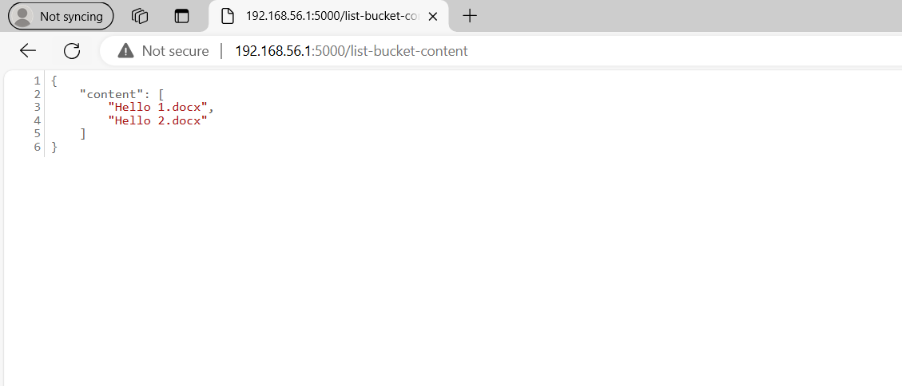  
  
  
But was not running through public ip of AWS instance  
Aws service run :  
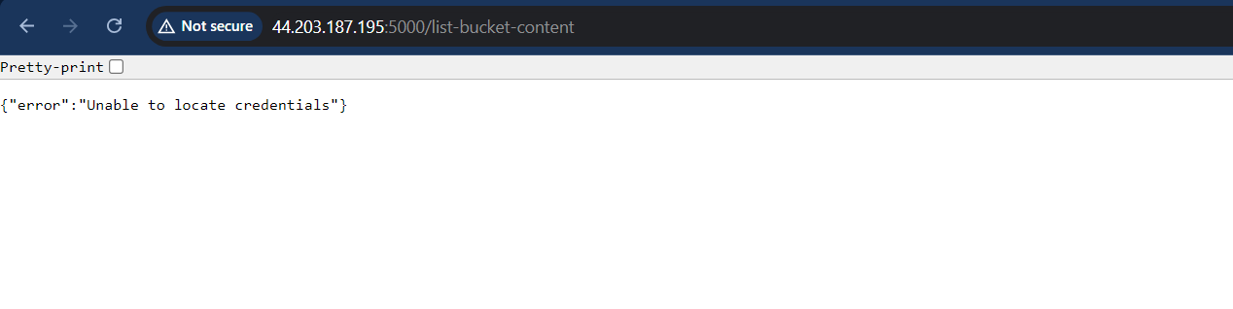  
**current status** : stuck over credentials error, tried multiple fix but still issue persists. Need to investigate further